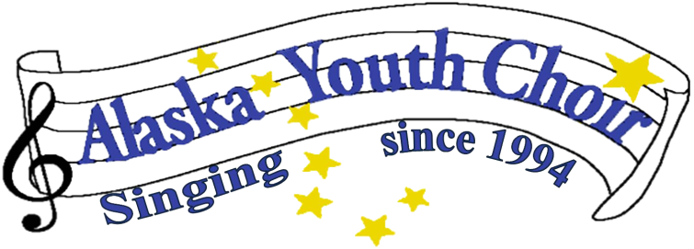

Alaska Youth Choir 2022 – 2023 Calendar
Fall Schedule
September – 6th 6pm 1st Rehearsal at Faith Lutheran Church
All Subsequent rehearsals will be every Tuesday at Faith Lutheran/Zoom @6pm
14th 6:30pm AYC Board Meeting - ZOOM

October – 12th 6:30pm AYC Board Meeting - ZOOM

November – 1st Raffle Tickets available
9th 6:30pm AYC Board Meeting - ZOOM
27th Raffle Tickets Due
29th Holiday Concert 6:30pm Faith Lutheran Church (Call time 6pm)
Raffle to be drawn at concert
Winter break following concert

December – 6th Backup - Holiday Concert 6:30pm Faith Lutheran Church (Call time 6pm)
This is a Backup Concert date if Classes are cancelled
14th 6:30pm AYC Board Meeting - ZOOM
Winter break following concert

Spring Schedule
January – 11th 6:30pm AYC Board Meeting – ZOOM
31st 6pm 1st Rehearsal at Faith Lutheran Church
All Subsequent rehearsals will be every Tuesday at Faith Lutheran/Zoom @6pm

February – 8th 6:30pm AYC Board Meeting – ZOOM

March – 8th 6:30pm AYC Board Meeting – ZOOM
20th – 24th Spring Break – No Rehearsals

April – 12th 6:30pm AYC Board Meeting - ZOOM
? Folk Festival (Day & Time TBA)
18th Spring Concert 6:30pm Faith Lutheran Church (Call time 6pm)
25th Last Rehearsal Wrap Up -Community Trash Pick Up same time and place as Rehearsal
25th Backup - Spring Concert 6:30pm Faith Lutheran Church (Call time 6 pm)
This is a Backup Concert date if Classes are cancelled

May – ? Performance at UAS Community (Day &Time TBA)

10th 6:30pm AYC Board Meeting – Faith Lutheran
Weekly Rehearsal Schedule (Tuesdays):
6pm – 7pm All Choirs

